**Setting up Environments for Practice**

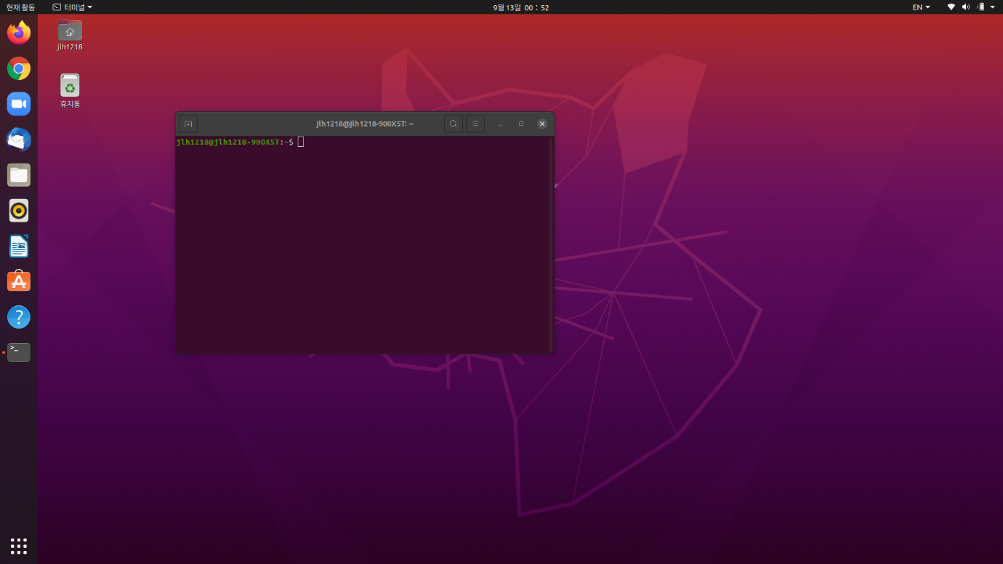

I already use Ubuntu 20.04 LTS. So, I capture and submit only the screen that has been installed.